
“Ambitious Leaders – stronger together”

Energy Saving in Redbridge Schools

The challenges facing schools in current times are exacerbated by unpredictably high energy costs. Redbridge Educational Partnership have put together some guidance for schools which may help schools reduce their energy costs in the future. We have included as many options as possible that schools may easily implement and some templates that may be usefully employed to support energy reduction.

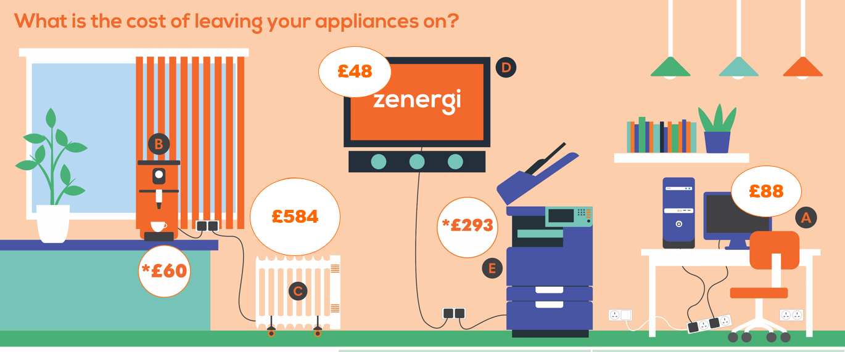

Cost if left on 4
hours per day over
6 months

Energy Saving Opportunities
Whole school audit
Carry out an audit of the whole school using the pro-formas provided on pages 17 to 20 to obtain an overall view of the energy usage by the school and ideas for how you can reduce this.

More details on how to implement the most important and effective actions are in the ‘Opportunities’ below.

Record the actions you are going to take for each opportunity in the action plan template on page 23. An example of an action plan is on page 24.

Opportunity 1: How much energy is the school using on a daily basis?

How to complete your 10-day electricity audit
Before you start taking any actions to reduce energy usage in your school you need to know how much energy the school is currently using on a daily basis so you can see if your actions have any impact on this. Schools usually receive quarterly electricity and gas bills which don’t provide enough detail of energy usage for the aims of this programme and it’s a long time to wait to see if your actions are being successful in reducing your energy consumption. Reading meters regularly also helps to identify unusual peaks in usage that can then be more easily identified e.g. a coffee morning, and explained or if not investigated.

An easy way to obtain this information is by taking daily meter readings for a suggested 10 school day period before you start any actions. You’ll then have a base line to work from. Follow this by carrying out your chosen actions for a few weeks and then retake meter readings for another 10 school days. You’ll then be able to compare energy usage from before and afterwards to see if your actions have been successful and by how much.

To read your meter/s
Choose a weekday to start and read the meter/s after everyone has gone home and again the following morning before everyone arrives for a period of 10 school days. This will enable you to calculate the daytime, overnight and weekend usage of the school. You do not need to go into school over the weekend as by reading the meter/s on a Friday at the end of the day and then first thing on a Monday morning, the difference between the two readings will provide you with the weekend usage.

The timings of the readings will depend on your school, for example, if you have a Breakfast Club, Afterschool Club or Afterschool Activities. If outside organisations hire your premises you might consider taking readings before and after to obtain an idea of how much they’re consuming and either deduct from your total or encourage them to reduce their energy usage as well.

Record the readings on the ’10 school day meter readings’ template on page 16.

Repeating this after a few weeks will enable you to see if your actions have made a difference.

Finding historical energy data
Some energy suppliers can provide historical data on energy usage over several years in table and graphic form of kWh and costs per month.

A similar activity can be carried out for gas usage but this will vary greatly between seasons.

Opportunity 2: Labelling light switches

Common practice in a school is for all of the lights in a classroom/hall to be automatically switched on when entering the room without checking to see if there is sufficient natural light and whether some or all of the lights need to be switched on.

Often with new LED lighting all of the lights are on one switch but if lights are arranged in banks or rows in a room with multiple light switches it’s possible to switch rows of lights on or off independently therefore only using lights as necessary, reducing energy usage, emissions and saving money. This can be achieved by carrying out the following:

- With pupils for the Action Team identify which rooms have multiple light switches.

- On a day when there is a lot of natural daylight, not too sunny nor too overcast proceed as follows:

- Turn off all of the lights and starting furthest from the window, switch each row back on, one at a time, estimating each time if there is enough light to work with.

- When there’s agreement that there is sufficient light in the room, stop switching on.

- Consult with the class teacher for each room to get agreement on which rows of lights could normally be left switched off.

- Circular red stickers or red crosses to be used to mark the switches of lights to be left off once agreement has been reached so that pupils and staff will know that these lights are NOT to be switched on during normal daylight hours.
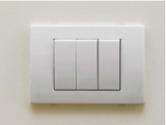
- Green circular stickers or green ticks could be used to mark the switches for lights that are needed for normal usage.

- Red circles or red crosses – Do not switch on.

- Green circles or green ticks – Switch lights on as necessary.

- This will need to be trialled to ensure all staff are happy with the system and once approved the stickers could be replaced with red and green permanent marker pen as appropriate.

- Common sense has to be used as light levels vary during the day and time of year.

Additional areas to be included in this activity:
- Light switches in corridors. Lights in corridors are often left on continuously and their use needs to be monitored with lights being switched off as daylight levels increase.

- Lights above cupboards offer little benefit therefore can usually be left off permanently.

- Lights are often left on in storage cupboards and should be switched off after use.

- Toilets are problem areas with lights often being left on all day.

Motion sensors that can be fitted to lighting systems cause the lights to come on when movement is detected. They are a good idea in cupboards and toilets where there is no natural daylight.

Installing them in areas where there is natural daylight can result in lights coming on unnecessarily when there is sufficient natural daylight. If motion sensors are to be fitted, a recommendation would be to fit them in conjunction with lux, or light level, sensors that will only activate the lights if the level of natural light is below a certain level. Ensure that your school has instructions for turning lights off during holidays.

Something else to consider when installing motion and lux sensors is that staff and pupils will not be learning the behaviour change required as the sensors are doing the work for everyone and the behaviours will not be replicated at home and in the wider community.

Arrange an assembly with pupil participation to inform everyone of what you are trying to achieve and their role in this.
Organise a poster and sticker competition for winning posters and stickers to be displayed all around the school to remind everyone constantly to only use lights as necessary and to switch off after use.

How much could be saved?

Lighting accounts for approximately 20% of a school’s electricity costs therefore reducing the number
of lights being used will save a proportion of the 20%.

To give you an idea of what can be saved carry out the following:

Calculate 20% of your annual electricity bill £ A

Approximate % of lights that will be, or remain switched off % B

Amount of money that could be saved is A x B / 100 = C £ C

Other methods of reducing energy from lighting

- Upgrade lighting to energy efficient Light Emitting Diodes (LED). The reduction in energy usage and costs are substantial and enable a very short payback period. For example, a 60W light bulb costs £17 to run for 2,000 hours whereas a 12W LED bulkhead light costs £3.40.

- Install Solar Photovoltaic Panels (Solar PV) but only after doing all you can to reduce the electricity consumed in the school.

Opportunity 3: Switching off lighting when not needed

Lights are often left on in schools when there is enough natural daylight in the room and when pupils leave the classrooms. If the room is to be in use afterwards it’s sensible to leave the lights on but often the room is left unoccupied with all the lights left on. Modern lighting can be switched on and off as required.

Windows can be obscured by displays and blinds resulting in lights being switched on when natural daylight could be used instead. Blinds are closed when TVs and interactive boards are used and lights switched on after use rather than opening blinds.

Taking the steps below will help your school make the best of natural daylight and reduce the use of artificial lighting saving energy, costs and emissions.

- Each class or tutor group teacher to arrange for there to be an energy monitor for each group either by asking for volunteers or by selecting a pupil. In some cases, it may have to be the teacher themselves or learning support assistants.

- The role of the energy monitor with the agreement from the teacher is to:

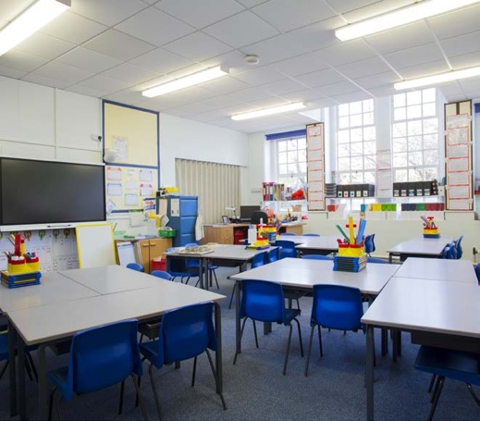
- Monitor the level of natural daylight in the classroom during the day and if there is sufficient daylight, to switch off unnecessary lights.

- To turn lights off if the classroom is to be left unoccupied after the lesson.

- To ensure blinds are opened rather than turning lights on following the use of a projector / TV etc.

- Make sure that no posters or displays on windows prevent natural daylight entering the room.

How much could you save?

If the school doesn’t already have a switching off policy, you could save up to 10% of your
electricity bill.

To give you an idea of what can be saved carry out the following:

Find out what the school’s annual electricity bill is = £ A

The amount of money you could save each year (B) is found by A / 100 x 10 = £ B

Opportunity 4: Out of hours survey
Schools should only be using a small amount of electricity overnight for items such as servers, refrigerators and freezers. Your school is probably leaving other items on overnight, weekends and holidays which can be as much as 20% of your daytime use.

Carrying out an out-of-hours survey will help you to identify these items so you can ensure they are switched off.

This can be achieved by carrying out the following:

- Find out what your current overnight use is from your electricity meter readings carried out previously.

- After school one-day survey of all the rooms in the school without warning staff using the template on page 17 to record the items and the number of those items that have been left on that day. Look particularly at lighting photocopiers, printers, IT equipment, electric heaters, water heaters, overhead projectors, interactive boards, kitchens, exterior lighting and don’t forget the boiler room and other service areas.

- Report your findings to everyone in the school as it will raise awareness of how much equipment the school has, that a lot of equipment is being left on and the potential savings to be made.

- Encourage everyone to switch items off fully at the end of the day rather than leaving them on standby.

- Ask pupils to design posters to remind everyone to do this. At the same time launch a reward scheme so successes can be celebrated room by room, class by class in celebration assemblies and keep raising awareness with staff in staff meetings.

Opportunity 5: IT Equipment Switch-Off
Following an out of hours audit the next step is to label IT equipment to identify items that everyone can turn off when possible.

- Working with pupils in your Team, identify all IT equipment in all areas of the school.

Using the template on page 18 make a list of each item and numbers of each, in each room of the school. Make a note if you feel the item is being left on unnecessarily.

- Place a coloured sticker on each item as follows:
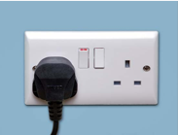
- Green for equipment which should be switched off when not in use (for example, televisions, computers, laptops, projectors and interactive whiteboards).

- Orange for equipment which should be switched off after checking that no-one is using it (for example, the teacher’s computer)

- Red Do not touch. For equipment which should not be switched off (for example, a freezer during term time or the main server).

- Once the stickers have been placed on all the plugs and switches of IT equipment inform the whole school of your findings and what you have done emphasising what the different coloured stickers/shapes mean and that anything with a red sticker must NOT be turned off, anything with an orange sticker can be turned off if appropriate but anything with a green sticker can be turned off if no-one is using it.

Tell them that they are allowed to turn items off if they follow this procedure and are sensible.

Most people are shocked to discover how much electrical equipment the school owns and how much is being left on consuming energy unnecessarily.

- Remember to celebrate your successes.

In addition, consider:

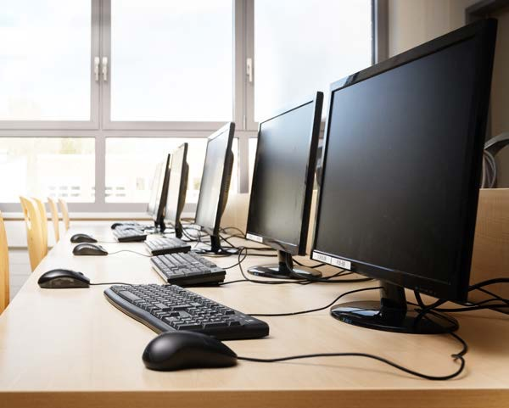
- Purchasing a timer plug for laptop trolleys to ensure they’re not left on unnecessarily. The timer can be set to recharge the laptops for the required number of hours at the end of the day so they are ready for use in the morning. Continuous charging wastes energy and money, shortens the life of the laptop batteries and is a FIRE RISK.

- Allowing a computer network manager to switch off all machines remotely after an agreed time in the evening. This will ensure that all computers are switched off.

Watts (W)
Power rating of an electrical item and can usually be found on the product sticker

Kilowatt hour (kWh)
A measure of electrical energy equivalent to a power consumption of 1,000 watts for one hour, i.e. if you use a 1,000W item for one hour you’ll consume 1 kilowatt of electrical energy, if you use a 500W item for 2 hours you’ll use 1kWh of electrical energy.
How much do electrical items cost to run?

The table below provides an indication of the approximate costs of running individual items of IT equipment which will help to obtain co-operation from everyone. The figures are for running costs of each item while the school is open, which is on average 2,000 hours a year, 200 days for 10 hours a day.

Remember to multiply the number of items by the cost of each item to obtain annual overall running costs.

To calculate how much it costs to run an electrical
item:

Power rating of item in Watts/1,000 to convert to kWh
x hours of use x cost per kWh/100 = cost in £.

For example:
Cost of running a 100W computer during school
opening times @ 14p per kilowatt hour (kWh) =

100W/1,000 = 0.1kWh x 2,000 hours x 14p per kWh
= 2,800p/100 = £28. This is for each computer.

Item of Equipment | Annual costs (£) per item for 2,000 hours usage
Desk top computer and monitor 100W | 28
Laptop 50W | 14
LCD Television large screen 200W | 56
Smartboards/Interactive whiteboards | 38
Large photocopiers 1,400W in use for e.g. 100 hours | 20
Fridge 80W | 22
Chest Freezer 150W | 42
60 Watt Light bulb x 1 | 17
12W LED bulkhead light | 3.40
5ft T8 fluorescent twin 124W | 35
6ft LED batten 31W | 9

In standby mode the energy use would be much lower but by turning off all PCs when not in use overnight, at weekends and in the holidays would save a considerable amount of energy and cost as well as reducing the risk of fire.

Monitors use approximately a third of the energy used by a computer so by turning them off when leaving desks during the day can save a considerable amount of energy. You will not lose your work as the computer is still operating.

Calculate the running costs of electrical equipment in your school by using the template on page 15.

Item | Wattage of item/1000 = kWh | Hours of use average 2,000 hours | Cost per kWh (on energy bills) | Running cost for 2,000 hrs Each item | Number of items in school | Total cost of items for year
Example:  Desk top computer | 100W / 1000 = 0.1 kWh | 0.1 kWh x 2000 =  200 kWh | 14p per kWh | 14p x 200 kWh = 2,800p/100  = £28 | 100 | £28 x 100 = £2,800
Opportunity 6: Heating audit
- Reducing heating times by 1 hour per day can reduce heating costs by 10%
e.g. half an hour in the morning and half an hour in the afternoon.

- Reducing the heating temperature by 1⁰C can save 10% on heating costs

- Carry out a heating audit of every room in your school using the template on page 19. For each room try to conduct the audit with the people who use that room the most to highlight any issues and record it with them on the template.

- Check with the site manager/caretaker/business manager that the heating times match with the opening hours of the school so that it isn’t being heated when unoccupied.

Recommended temperatures for different parts of the school are listed below:

Area | Recommended temperature in ⁰C
Classrooms and dining areas | 18
Multi-purpose halls | 15 – 18
Gyms and sports halls | 15
Medical rooms | 21
Offices and staff rooms | 18
Corridors and toilets | 15

- Ensure that radiator valves (TVRs) are operating so that radiators can be turned down if the room is too hot rather than opening windows and allowing the heat to escape. Open doors onto indoor corridors in addition to turning down TVRs if necessary as another method of reducing the temperature rather than opening windows.

- Encourage everyone to adhere to these temperature guidelines and not turn the thermostat up if they’re cold. Encourage them to wear more clothes instead.

- Provide thermometers for each room so you know what the temperature is.

- Bring children into the classroom through internal doors rather than external doors that lead directly into the classroom.

- Ensure that exterior doors are not left open if the heating is on.

- Do not place heat emitting items such as photocopiers under thermostats as this will create a false reading and the heating will not come on when needed.

- Do not block radiators with furniture such as desks, tables and cupboards etc. as this prevents the heat from being distributed effectively and can cause the heating system to operate more than is necessary.

- Can the heating be controlled in the room? If not report it to the site manager to investigate.
Checklist to identify actions
This checklist will help you to assess your school and identify areas needing improvement that will result in energy, carbon and monetary savings.
You’ll probably need the support of the school business manager and site manager / caretaker to answer some of the questions.
Details of each classroom / area can be recorded on the audit sheets.

Room Type | Energy Saving Opportunity | Result / Answer
General information | When was the school built?
General information | What type of construction is it? Stone, brick, panels, wooden?
General information | What type of glazing does the school have – single, double, triple or secondary glazing or a mixture
General information | Who has responsibility for monitoring energy consumption and do they read meters regularly rather than waiting for quarterly bills?
General information | What is the average monthly electricity usage and cost? Usage (kWh) | Cost (£)
General information | What is the average monthly gas usage and cost in the heating season Usage (kWh) | Cost (£)
General information | Where are the electricity and gas meters?
General information | Electricity VPN (meter) number/s? If more than one meter which areas of the school does each meter cover e.g. kitchen, pre-school, main building, mobile classrooms?  Gas meter number/s  Are meters accessible for pupils to read as long as it is safe to do so?
General information | Are pupils involved in reading meters and monitoring the results?
General information | If the school is heated by oil how is the consumption measured - is there a gauge or is consumption based on annual usage from bills?
General information | Is information on energy shared with everyone in the school? If people know how much energy is being used and how much it costs they are more likely to get engaged with trying to reduce energy consumption. Energy data can be used for producing graphs in maths lessons for display. This also raises awareness for everyone on energy usage.
General information | Lighting – As you carry out the audit of each room include information about lighting types in each room. For example, is lighting LED (Light Emitting Diodes), Fluorescent tubes? T12s, T8s or T5s or a mixture of both? LEDs are most efficient following by the T5s, T8s and T12s. The site manager should be able to help with this
General information | Do you have an energy or action team?

Room Type | Energy Saving Opportunity | Result / Answer
General information  (continued) | Does your school have an environmental and / or energy policy?
General information  (continued) | Do you run activities to engage and raise awareness?
Boiler Room Heating | What form of heating does the school have? Mains, gas, lpg, propane, oil, electricity, biomass or a mix?
Boiler Room Heating | Are boilers regularly serviced?
Boiler Room Heating | Are pipes and valves fully insulated in the boiler room?  Boiler rooms are NOT supposed to be warm. Frost protection should be in place
Boiler Room Heating | Have heating times been matched to the occupancy of the school? If the heating period is extended for an evening event make sure the timer is set to normal times afterwards.
Boiler Room Heating | What time does the heating come on in the morning? What time does the heating go off?  What time does school open in the morning? What time does school close? | AM PM  AM PM
Boiler Room Heating | Is your hot water storage tank fully insulated?
Boiler Room Heating | What temperature is the water heated to? It must be heated to a minimum of 60⁰ C but needn’t be higher than this
Boiler Room Heating | Are point of use electric water heaters turned off over weekends and during school holidays?
Building exterior | Are external lights switched off during the day?
Building exterior | Are controls for exterior lights checked regularly to ensure they match occupancy periods and hours of daylight?
Building exterior | Are your exterior doors and windows free from gaps which lead to heat loss and draughts?
Building exterior | Have unnecessary opening windows been permanently sealed?
Building exterior | Do door closers function properly?
Building exterior | How do children enter classrooms – directly from the outside or through a cloakroom?
Building exterior | Are windows and skylights cleaned regularly to allow maximum natural daylight in?

Room Type | Energy Saving Opportunity | Result / Answer
Classrooms,  IT Suites and  Libraries | During the heating season is the temperature of classrooms, libraries and IT suites 18⁰ C?
Classrooms,  IT Suites and  Libraries | Are heating emitters (radiators, convectors etc.) free from obstructions such as tables, storage and bags?
Classrooms,  IT Suites and  Libraries | If you have thermostatic radiator valves, are they set to a medium setting, e.g. 3?
Classrooms,  IT Suites and  Libraries | If there are thermostats in the rooms are they working and are they set at the appropriate temperature?
Classrooms,  IT Suites and  Libraries | Do windows remain closed when the heating is on?
Classrooms,  IT Suites and  Libraries | Is your school free from supplementary heaters (i.e. electric plug-in heaters)? The use of these indicate an inefficient heating system
Classrooms,  IT Suites and  Libraries | Are any parts of the school too hot? If so where?
Classrooms,  IT Suites and  Libraries | Are any parts of the school too cold? If so where?
Classrooms,  IT Suites and  Libraries | Before lights are turned on in the morning is consideration given as to whether they need to be turned on?
Classrooms,  IT Suites and  Libraries | If lights are turned on in the morning – does anyone turn them off as the level of daylight increases during the day?
Classrooms,  IT Suites and  Libraries | If you have multiple light switches in rooms are the ones that don’t usually need to be on clearly labelled to prevent them from being used unnecessarily?
Classrooms,  IT Suites and  Libraries | Are you satisfied that none of the rooms are over lit?
Classrooms,  IT Suites and  Libraries | Check the temperature of air conditioning units if you have them; are they set to a temperature of no less than 24⁰ C?
Classrooms,  IT Suites and  Libraries | Where IT suites have air conditioning, are windows and doors always kept closed?
Classrooms,  IT Suites and  Libraries | Is IT equipment such as PCs, laptops, whiteboards, projectors and TVs always switched off when not in use?
Classrooms,  IT Suites and  Libraries | Have you considered installing plug-in time controls to IT equipment such as laptop charging trolleys, photocopiers?
Hall and  Theatre | Are blinds on high level windows open to allow natural daylight to enter?
Hall and  Theatre | Are lights switched off after assemblies when the hall is empty?
Hall and  Theatre | If you have multiple light switches are only necessary lights being used rather than all of them?
Hall and  Theatre | Is all specialist equipment such as spotlights, projectors etc. turned off when not being used?

Room Type | Energy Saving Opportunity | Result / Answer
Office and  Reception  areas | Is non-essential lighting switched off at all times, for example lights in well day-lit reception areas?
Office and  Reception  areas | Are lights always switched off when these areas are unoccupied, e.g. before office staff arrive, whilst at lunch and when they leave?
Office and  Reception  areas | Is IT equipment such as printers, photocopiers switched off overnight?
Office and  Reception  areas | Are plug-in timers fitted to any electronic equipment such as photocopiers and printers in this area?
Office and  Reception  areas | Are computer monitors switched off when not in use?
Office and  Reception  areas | Have any unnecessary plug-in heaters been removed?
Kitchen | Ovens and hobs heat kitchens therefore if there is a thermostat in the kitchen turn it down to between 16 -18⁰ C
Kitchen | Is catering equipment switched off immediately after use, including extractor fans?
Kitchen | Where possible are fridges and freezers located in areas away from heat sources?
Kitchen | Where possible are fridges and freezers emptied and switched off during holiday periods with doors propped open? If multiple appliances are present, combine the contents so some can be switched off
Kitchen | Are fridges and freezers defrosted regularly?
Kitchen | Is cooking equipment labelled with pre-heat times and not left on unnecessarily?
Kitchen | Is hot water set to an appropriate temperature of non-occupancy?
Staff Room and  Common  Room | Are lights always switched off during periods of non-occupancy?
Staff Room and  Common  Room | Are kettles, toasters, coffee machines etc. switched off at the plug overnight, weekends and holidays?
Staff Room and  Common  Room | Are plug-in timers fitted to any electronic equipment such as photocopiers and printers in this area?
Staff Room and  Common  Room | Have any unnecessary plug-in heaters been removed?
Staff Room and  Common  Room | Are fridges emptied for the summer holidays (and door propped open)?

Annual running costs of electrical items

Below we have provided the annual running costs for some key items found in schools. Count up the number of these items that the school has and multiply by the annual cost to find the total annual cost for those items.
For items not listed in the table use the calculation given in the template “Calculating the running costs of an electrical item”.
Item | Wattage | Number of items | Running cost per item for 2,000 hours (£) | Total cost of items for year (£)
e.g. laptop | 50 Watts | 100 | 14 | 1,400
Desk top computer and monitor | 100 |  | 28
Laptop | 50 |  | 14
Ipad/Tablet | 10 – 20 |  | 2.80 – 5.60
Plasma TV 42” screen | 240 |  | 68
Large photocopiers 1,400W in full use for e.g. total of 500 hours over a school year | 1,400 |  | 98
Laser printer  (continuous) | 500 |  | 140
Fridge | 150 |  | 42 or if left on continuously during holidays for 8760 hours (365 days x 24 hours) = £184
Chest freezer – large 200 – 449 litres | 300 |  | 42 but often left on continuously during holidays for 8760 hours (365 x 24) so could be higher cost of £368

Calculating the running costs of an electrical item

To calculate how much it costs to run an electrical item:

Power rating of item in Watts/1,000 to convert to kWh x hours of use x cost per kWh/100 = cost in £. Wattage (W) can be found underneath or on the back of an item. Take care when searching for this.

Example:
Cost of running a 100W computer during school opening times @ 14p per kilowatt hour (khw)

100W/1,000 = 0.1kWh x 2,000 x 14p per kWh = 2,800p/100 = £28.

This is for each computer

Some running costs have already been calculated for you in the table “Annual running costs of electrical items”.

Item | Wattage of item / 1000 = kWh | Hours of use average 2,000 hours | Cost per kWh (on energy bills) | Running cost for 2,000 hrs Each item | Number of items in school | Total cost of items for year
Example:  Desk top computer | 100W /1000 = 0.1 kWh | 0.1 kWh x 2000 =  200 kWh | 14p per kWh | 14p x 200kWh = 2,800p / 100 = £28 | 100 | £28 x 100  = £2,800
10 School Day Meter Readings
Your electricity meter records the number of units in kWh (kilowatt hours) of electricity you have used and you are charged for each unit. By taking readings morning and evening you can calculate daytime, overnight and weekend usage. A similar exercise could be carried out for gas meter readings.
Date of Reading | Morning Reading  Time am | Closing Reading  Time pm | Reading  Digital meter from left to right Dial meter 5 dials from left to right |  |  |  |  | Units (kWh) used since last reading
e.g. 30/1/20 | 8.00 am |  | 5 | 4 | 3 | 2 | 1
 |  | 6.00 pm | 5 | 4 | 3 | 2 | 6 | 5 kWh  (during the day)

Out of hours energy audit
Listing items left on when school is closed. Complete a table for each room
Room number or name | Item left on | How many of these items have been left on?
e.g. 15 | Computer and monitor | 3
 | Monitors only | 2
School IT and appliance audit

Room number or name | Type of IT equipment and appliance | Number / Type  Yes / no etc.
e.g. Class 8 | Computers (add other items as relevant to the room) | 15
Point of use electric water heater – (can be inside a cupboard)
Is it switched off over weekends and during school holidays?
School lighting and heating audit
Room number or name | Type of lighting and number | Number / Type  Yes / no etc.
e.g. Class 8 | Number of lights | 15
 | Type of lights LED / T5 / T8 / T12?
 | Number of light switches
 | Motion sensors for lights?
 | Lux sensors for lights?
 | Posters / blinds blocking windows?
 | Are lights switched off when the room is empty?
Heating | Type of heating – gas central / oil / lpg / electric
 | How many radiators?
 | Is there a thermostat?
 | Does it work?
 | What temperature is it set at?
 | Is a heat source placed below the thermostat such as a computer or laptop charging trolley? If so remove the heat source if possible as it will affect the functioning of the thermostat
 | Are there valves on the radiators for controlling the temperature? (TRVs)
Do the valves work?
If not inform the site manager / caretaker
 | Type of windows – single / double or triple glazed
Have any of the windows got condensation inside the glazing?
If so, report to the site manager as this means the unit has failed
Can the windows be opened for ventilation?
If not how is the room ventilated?
 | Is furniture in front of radiators blocking the heat?
 | Exit from the room via an internal door such as e.g. into a cloakroom or to an external door?
 | If external door is it self-closing?
Is the room often too hot or too cold?
If so what time of the day?
 | Which direction is the room facing – north, south, east or west?

Electric Heater Audit
Listing all portable electric heaters in the school
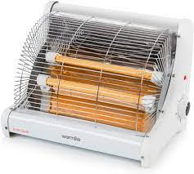
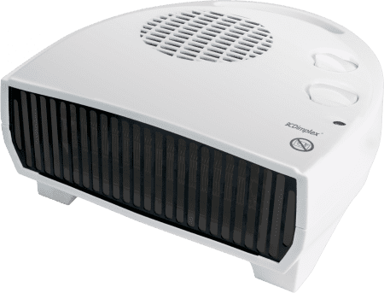
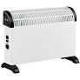
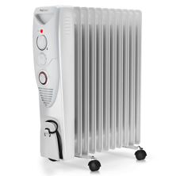
Portable oil filled Portable electric Portable fan Portable
radiator convector heater Heater radiant heater

Room number or name | Type of Heating | Number of Heaters
e.g. Room 2  Bumblebees | Portable fan heater | 1
e.g. Office | Portable oil filled radiator | 1

Types of renewable energy technologies

Solar Photo Voltaic (PV)
Solar PV generates renewable electricity with zero carbon emissions from sunlight. Electricity will be generated every day during the hours of daylight, albeit at a reduced rate when the sky is overcast.

Panels can be mounted on the roof of your school onto a south, southeast or southwest facing roof to help reduce your electricity bill and your carbon emissions. They can also be mounted on the ground.

Kilowatt peak (kWp) – Solar PV systems are described in terms of their size – that is, the maximum number of kilowatts of electricity that they can produce. So, for example, a 10kWp system can generate up to 10 kilowatts of power. Bear in mind though, that the panel’s peak output will only be achieved in bright, sunny conditions. For the most of the year the output will be much less, typically around 10% of peak output (when achieved over 8,760 hours per year).

Solar Thermal
A Solar Thermal system works by harnessing the sun’s energy and converting it into heat which is then transferred into your home or businesses heating system as hot water or space heating. Solar thermal panels are used in conjunction with a boiler, collector or immersion heater. The solar collector will use the sun’s rays to heat a transfer fluid which is a mixture of water and glycol, to prevent the water from freezing in the winter. The heated water from the collectors is pumped to a heat exchanger inside a water cylinder. The heat from the exchanger will then heat the water inside the cylinder.

Air Source Heat Pump
Air Source Heat Pumps (ASHP) absorb heat from the outside air to heat your building and hot water. They can still extract heat when air temperatures are as low as -15⁰C. Heat from the air is absorbed at low temperature into a fluid. This fluid passes through a compressor, increasing the temperature, and transfers that high temperature heat to the heating and hot water circuits of the building.

There are two main types of ASHP: air-to-water and air-to-air. Choosing an air-to-water or an air-to-air system will determine the type of heat distribution system you need.

Ground Source Heat Pump
Ground Source Heat Pump systems are made up of a ground loop (a network of water pipes buried underground) and a heat pump at ground level.

A mixture of water and anti-freeze is pumped around the ground loop and absorbs the naturally occurring heat stored in the ground. The water mixture is compressed and goes through a heat exchanger, which extracts the heat and transfers it to the heat pump. The heat is then transferred to your building heating system. A ground source heat pump can increase the temperature from the ground to around 50⁰C, although the hotter you heat your water, the more electricity you’ll use. You can then use this heat in a radiator, for hot water, or in an underfloor heating system.

Wind Turbine
Wind turbines harness the power of the wind and use it to generate electricity. Wind turbines use large blades to catch the wind. When the wind blows, the blades are forced round, driving a turbine which generates electricity. The stronger the wind the more electricity is produced. The energy can be stored in batteries for use when there is no wind.

Biomass
Biomass is a renewable energy source, generated from burning wood, plants and other organic matter, such as manure or household waste. It releases CO₂ when burned, but considerably less than fossil fuels. Biomass is considered as a renewable energy source, if the plants or other organic materials being burned are replaced. It can be used to generate heat, electricity, be used in the form of wood-fuelled heating systems. It is important to note though, that biomass is only considered renewable if it comes from a sustainable source, where new plants are grown in place of those used for fuel. It’s also important to make sure that there are no unwanted negative impacts from producing the fuel, such as loss of valuable ecosystems.

Action Plan

As a result of reading this guidance and carrying out the survey for other opportunities, you will have identified the energy saving opportunities that are applicable to your school. Once you have selected the opportunities best suited to your school, you will be able to design your own action plan (below). You can use this to record the opportunities you have identified, the savings you expect to achieve, the people responsible for advancing this to the whole school and completion dates. Keep this plan updated as and when you complete the implementation of individual opportunities and when you identify new ones. A sample Action Plan is given on the following page.

Priority | Opportunity | Estimated Savings |  | Person Responsible | Expected Date of Completion | Education Opportunity
1
2
3
4
5
6
7
8
9
10
11
12
13
14

Action Plan Example

Example of how you could complete the action plan.

Priority | Opportunity | Estimated Savings |  | Person Responsible | Expected Date of Completion | Education Opportunity
1 | Lead person identified
2 | Energy Group formed adults and pupils |  |  |  |  | Student participation
3 | Stakeholders identified – people who need to know what is happening and whose support is ideally needed e.g. SLT, staff, eco lead, students, governor, caretaker, business manager
4 | Gatekeeper identified – people who can stop the project e.g. Head, SLT, staff, caretaker, business manager
5 | Meter readings am and pm |  |  |  |  | Student participation if safe to do so. Usage of data in lessons
6 | Lights switch on/off identification and labelling |  |  |  |  | Student participation
7 | Lights – avoiding unnecessary use – appointment of energy monitors |  |  |  |  | Student from each class or tutor group
8 | Audit of equipment in rooms |  |  |  |  | Student participation
9 | Out of hours audit – equipment left on overnight/weekends |  |  |  |  | Possible Student participation
10 | Labelling of equipment plugs
11 | Communication to whole school/college of actions to be taken and their part in it – assembly, newsletter, website |  |  |  |  | Student contributions and involvement
12 | Request for ideas for energy saving |  |  |  |  | Whole school
13 | 1 or 2 months later – reading of meters to monitor progress |  |  |  |  | Student participation if safe. Usage of data in lessons. Reporting to others
14 | Reporting results |  |  |  |  | Student participation

References:
The Energy Saving Trust

Sources:
Education Business
Pay Less Power
Crown Oil
The Department of Education
Schools Energy Audit

