The new ‘DfE Register ECTs’ service: information for Induction Tutors

The DfE online service that schools need to use to register ECTs and Mentors onto an ECTE programme has been recently updated. The changes will go live from 15th June 2026.
Web address: https://www.register-early-career-teachers.education.gov.uk/
Please note the following changes:

- One Induction Tutor but multiple users
Schools will still have one designated Induction Tutor, however, multiple users per school can log into the service using DfE sign-in and can take the same actions as the Induction Tutor.

- ECT start date and TRN validation
On the new system, when active, the Induction tutor will enter the date the ECT will start at the school. They will then enter the TRN and the service will validate the teacher’s details for the induction tutor to confirm and proceed.

- Appropriate Body, Lead Provider and Delivery Provider
The next layer on the site to complete is the confirmation of AB, LP and DP. These decisions are all set at the individual participant level, as opposed to one choice for the whole school. This gives schools greater flexibility about choosing different training partners for different ECTs.
When registering participants, you can choose to continue using a previous selection (see screenshot below):

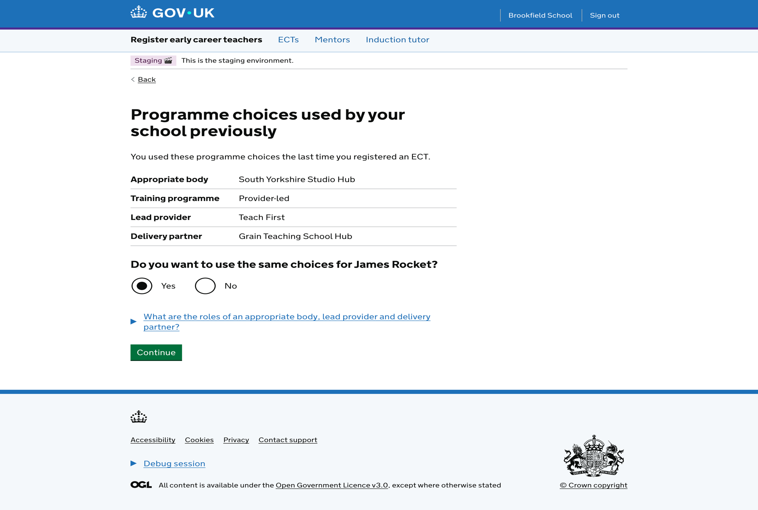

If you select ‘Yes’, this will usually create a partnership if missing.
If you select ‘No’, you will manually select the AB and LP but you are unable to select the DP; if you choose UCL and a partnership for the right cohort is already in place, the participant will gain the existing DP; if not, the DP will remain ‘blank’ on the participant’s record and UCL will need to create a partnership.

- Updating participant training programme and Lead Provider
Induction Tutors can now update a participant’s training programme directly on the portal, changing from school-led to provider-led and vice-versa.
An Induction Tutor can also update a participant’s Lead Provider directly on the portal, creating an “Expression of Interest”, but as mentioned before, they cannot individually select a Delivery Partner as this is determined by partnerships.
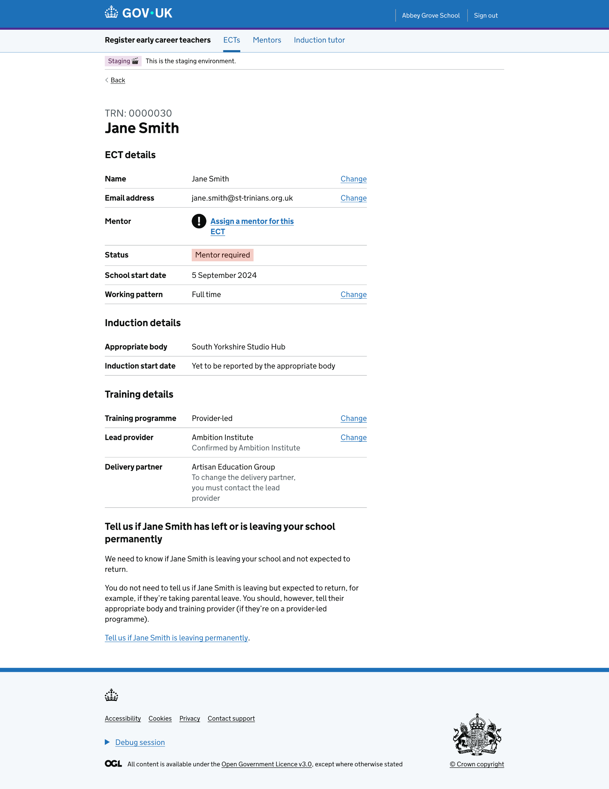

- Reporting a participant as leaving
Induction Tutors can now report a participant as leaving the school for any reason, previously they could only report moving schools.

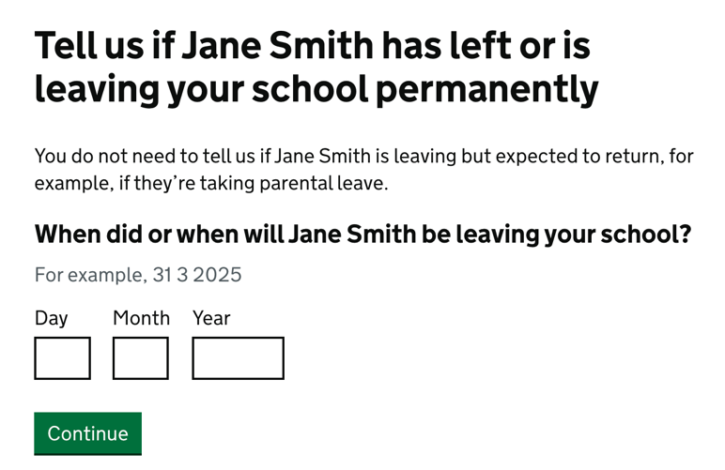
- Mentor registration
New mentors are registered by assigning them to an ECT (see image).

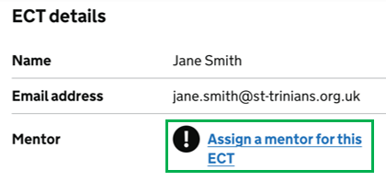

When registering a mentor, the service will let the school know if the mentor is eligible for mentor training.

- 2026 Registration
Launch of Cohort 2026: Cohort 2026 will become available 15th June (estimated).

Blocked Registrations:
- If an Induction Tutor tries to register an ECT and enters a start date of 1st June or later, the service will instruct the IT to retry from 15th June onwards.
- Between 1st - 14th June, the DfE Service will block all participant registrations while the DfE prepares for 2026 launch.

Further guidance from REP – please contact your Delivery Partner Director – Bob Drew ecfdirect@repmail.co.uk 0774 363 6218

